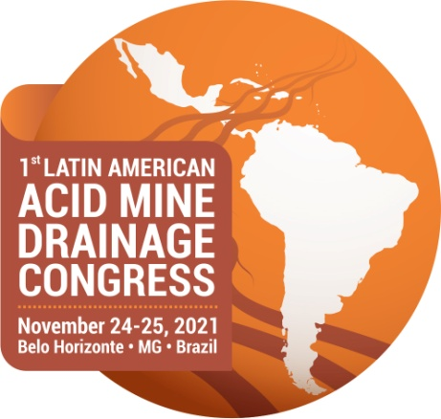

**TERM OF AGREEMENT FOR VIRTUAL PRESENTATION OF WORK**

I, _____________________________________________________________

commit to the **virtual presentation** of the technical paper entitled ___________________________________________________________________________________________________________________________________________________________________________________________________

at the 1st Latin American Acid Mine Drainage Congress (1st CLADAM), to be held from November 24-25, 2021, at the technical session designated by the Scientific-Technical Committee.

_____________________, _____________, 2021

_____________________________________

Signature

We request that this completed and signed term be sent to ÉTICA Eventos, 1st CLADAM Secretariat, by email at [eticaevento@gmail.com](mailto:eticaevento@gmail.com) by **November 3, 2021.**